

**BUILD A FLASHLIGHT**

**Project Overview:**

This activity highlights how electrical simple circuits work by having students construct a flashlight with common materials.

* **Appropriate grade levels:** 3rd and up
* **Set-up and initial gathering:**About 45-60 minutes
* **Total days:** 1 day

**Materials Needed per Student:**

* 1 craft stick with 2 lines
* 1 craft stick
* 1 long cut craft stick
* 1 short cut craft stick
* 3, 2-inch copper tape
* 3, 1-inch copper tape
* 1, 4-inch copper tape
* 1, 6-inch copper tape
* LED light bulb
* Scissors
* Electrical tape
* CR2032 battery

**Safety:**

* Children with young siblings need to keep the batteries out of reach

***Teacher notes:*** *When applying the longer copper tape leave the white part on the tape so it is easier to apply and then take the tape of the white part while taping it on the sticks.*

**Introduction**:

Without electricity our world would be a lot different. No lights, no TVs, no computers, no refrigerators – nearly all our comforts these days come from electricity. Most simply put, electricity is a flow of electrons, which are very small, negatively charged particles. Just like magnets where the negative poles are attracted to the positive poles, electrons are attracted to positive charges. When you look at a typical battery, each will have a ‘plus side’ and a ‘minus side’ – the electrons come out of the negative side, run through a conductive pathway to power something like a light, in the case of a flashlight, and then travel to the positive side of a battery. This is called direct current (DC), where the electrons only flow in one direction.

What is a conductive pathway? This is a material that has other charged particles that electrons can easily flow through – this material can be a liquid, like water, or a solid, like metal. There are also insulating materials, which are materials electrons can not pass through, like plastic, wood or rubber.

In this activity, you will be constructing a flashlight by creating a simple circuit for electrons to flow through in order to light up an LED light, using simple materials. During construction, think about what materials are conductors, and what materials are insulators. Also think about where the electrons are coming from.

**Procedure:**

Gather the craft stick with the two drawn lines, and 2 copper 2-inch strips. Using the drawn lines as a guide, tape the copper strips all the way around the craft stick at the marked lines.

Next, using the same stick, one 1-inch strip and the 4-inch strip of copper tape, tape the 1-inch strip on the short side vertical from the round top of the stick to the copper tape applied earlier (make sure the tape overlaps). Do the same with the 4-inch strip on the long side vertical. The already applied tape can overlap with the tape that we just applied perpendicular.

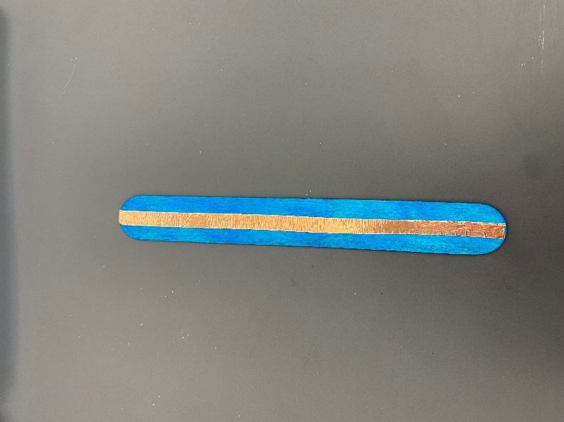Take the unmarked long stick and tape the 6-inch copper strip vertical on the stick from bottom to top.

Take the small stick and tape the 2-inch copper strip vertical from top to bottom on the stick.

Test the LED light by holding the battery in between the legs, have the short leg touching the smaller circle (-) and the long leg touching the bigger circle (+).

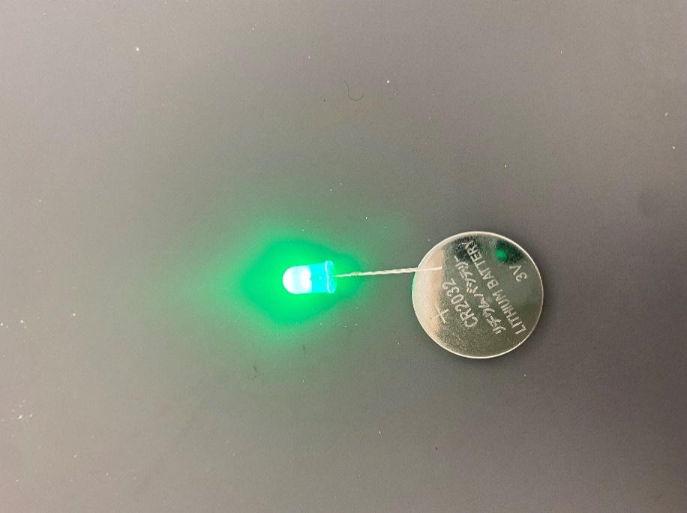

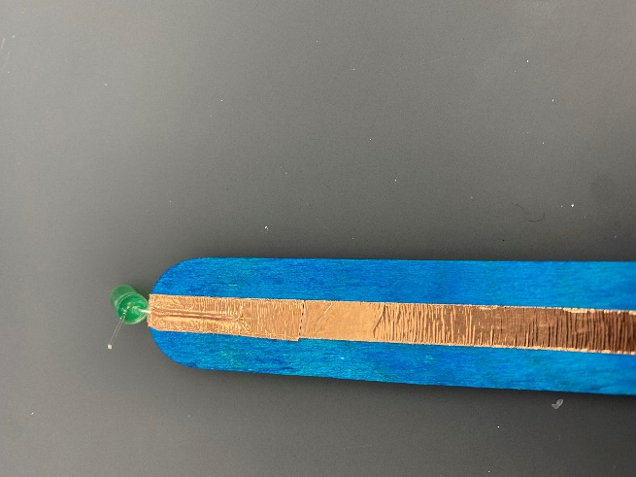Take the craft stick with the copper tape on the full length, and tape one leg of the LED with the 1-inch copper tape on the craft stick. The leg needs to touch the copper tape on the craft stick. To apply the LED easy tape the 1-inch copper tape on the leg and then push the tape on the stick to apply it to the copper strip.

Take the craft stick with the two horizontal copper strips, and tape the leg of the LED, with the 1-inch copper tape, on the long copper strip.

Take the small craft stick and apply electrical tape on the side without copper tape. Then, tape this over the two horizontal copper strips with the copper strips facing each other. The round end of the small stick will stay unattached and face the LED. The other end can touch the copper strip on the other stick.

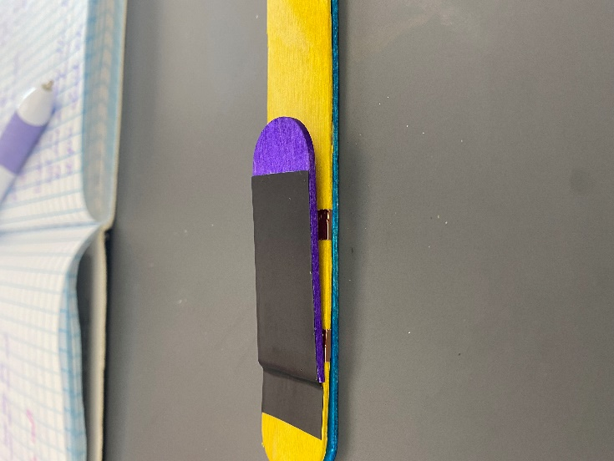

Slide the last stick in between the two long sticks and make all the round tops line up. Then, slide the battery in between the two long sticks keeping it at the end and pushing the small stick to the other sticks, press firmly to complete the circuit and ensure your LED lights up. If it doesn’t work, flip the battery over and try again.

Once you have confirmed that it works, tape the three sticks together with electrical tape, with the battery in between the two sticks so everything will stay in place.

You have now made your very own flashlight!

Here is a layout of all your materials:

**Questions to Ponder:**

1. How did the LED light up?
2. What did the copper tape do?
3. What is electricity?
4. Can you name things that need electricity?

**Science Standards Covered**

1. Structure and function in science
2. Making connections between science and other objects
3. Developing scientific reasoning