

**PLANT STUDIES**

**Project Overview:**

This experiment examines the various leaf structures of plants, and provides a fun hands-on activity that can yield a lovely gift!

* **Appropriate grade levels:** 2nd and up
* **Set-up and initial gathering:**60-120 minutes
* **Drying time:**About 10 days
* **Total days:** About 10 days

**Materials Needed for Each Pair of Students:**

* Field guide
* Plant press
* Notebook to use as field journal (not included)

**Safety:**

* Situational awareness while outside collecting specimens.

**Introduction**:

This lesson is devised to give students an overview of the basic leaf characteristics that botanists use to distinguish among different species of plants. It also covers the use of a plant press used for both scientific study of plants and for recreational purposes.

*Leaf Characteristics:* Scientists and naturalists look at many leaf characteristics to help them distinguish among different species of plants. One easy characteristic is to determine whether the leaf is a simple or compound leaf. Simple leaves consist of a single, undivided leaf whereas compound leaves are comprised of many leaflets attached to the stem. A true leaf also has a small, usually brown bud at the base; individual leaflets do not have these buds.

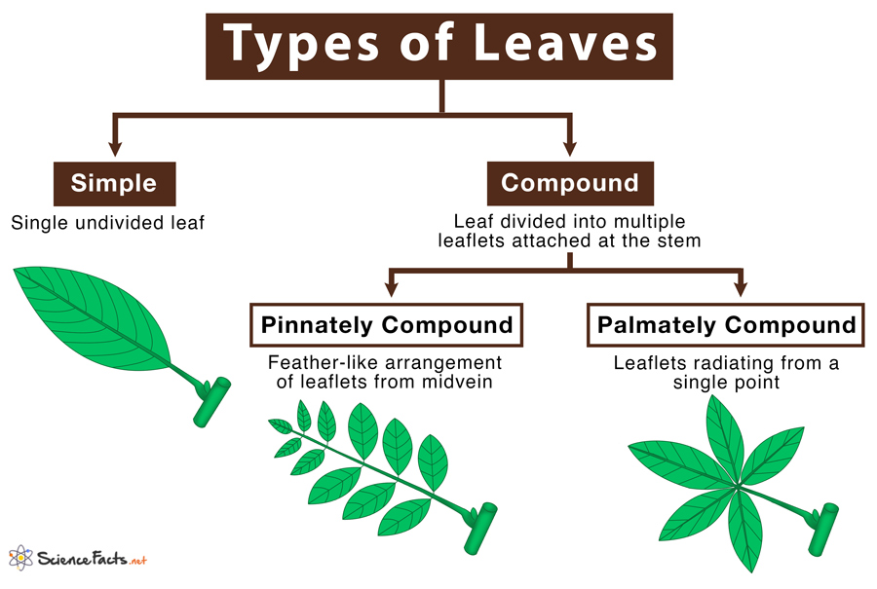

<https://www.sciencefacts.net/wp-content/uploads/2019/12/Types-of-Leaves.jpg>

Please visit <https://biodiversity.utexas.edu/news/entry/leaves> or see the attached guide from the University of Texas Austin Biodiversity Center for information and pictures on venation, leaf shape, leaf margins and leaf arrangement on stems.

*Plant Presses: Simplified version:* Throughout the 1800s and the first half of the 1900s, it became common for academic institutions to maintain pressed plants in large collections called herbaria. If pressed and maintained properly, these plant specimens can last for a hundred years or more. The NSU herbarium has some fern specimens that were pressed in the 1880’s!

**Procedure:**

# Where and How to Collect Plants

Roadside ditches make popular collection sites although they may be dominated by a few, "less-than-interesting" species. Collecting is illegal in city, county, state, and national parks. Collecting is allowed in most state owned wildlife and waterfowl production areas but you should seek permission from the state agencies first. Collecting is allowed in most national forests and grasslands but you again need to secure permission from the local administrative offices. Collecting may be done on private land but ONLY after first obtaining permission from the landowner. Be sure that there are many of the plant that you wish to collect (no collecting endangered or rare plants!).

Dig up as much of the plant as possible, including the root. Use a shovel or large knife to dig the plant out of the ground. Try to find a specimen with flowers and/or fruit present. Select individuals that have not been damaged by disease or insects. When collecting from trees and woody plants, select a "typical" twig with several leaves. Make a clean cut with a pruner rather than breaking off a branch to minimize tree damage.

Once you've got your specimen, knock/shake as much of the dirt from the soil possible. You may want to wash the roots gently with water to remove more of the soil. The biggest dangers to the specimen at this point are HEAT and DESSICATION. If you cannot press the plant immediately, wrap the roots in wet paper towels and place the plant in a plastic bag. Do not leave plants in your collection bag for any longer than you have to.

If you plan on keeping your plants as part of a collection, be sure to record the exact location where you collected the plants along with information on habitat etc. Herbarium specimens often have labels that include the scientific name, common name, a detailed description of the site where the plant was collected, and/or other information depending on the level of detail required.

***Note:*** *For this experiment, the provided plant presses are not quite big enough for a full plant, with root, collection. Instead, scissors may be used to clip a portion of the plant – try to include enough leaves so a leaf type can be determined. You may also clip a flower with a stem that contains a leave structure with it.*

# Preparing and Drying Your Specimens

As soon as possible, you should move your collections from the plastic bag into your plant press. A plant press can be purchased or constructed out of simple materials.

Plant presses have layers of various materials to aid the drying process. Between the boards, you want to layer in this order: cardboard – blotting paper (the thicker white paper) – parchment – specimen - parchment – blotting paper – cardboard. You can repeat this pattern times between the two boards. When your plant is ready for pressing, put it inside a section of parchment paper. Spread out the leaves and other parts as much as possible. It is helpful to have some of the leaves facing up and some facing down in cases where the leaf surfaces are different colors. Cover with the second piece of parchment, and layer as directed above. At NSU, the plant presses consist of two boards with cardboard blotters. You can place several blotters between the boards at the same time. Tighten the press with rope, straps, or a belt. Place the press in a warm, dry place. You may swap out the blotters if need be. Most plant specimens will dry in a few days. When dried, remove the plants from the blotters and store them (in the newspaper) until you are ready to identify them.

If you want to keep your plant specimens or include them in a larger collection, you can mount them on herbarium paper. Use clear glue to secure as much of the plant to the paper as possible. Add a label with the information outlined above.

**Additional Resources**:

Leaf identification guide: <https://www.imom.com/printable/leaf-identification-game/>

Sioux Falls Tree Guide: <https://www.siouxfalls.org/search?q=tree%20guide>

Tree Finder: A Manual for Identification of Trees by Their Leaves (an oldie but goodie, with great drawings of structures needed for ID). Available on Amazon.

Note: There are a variety of books available for identifying wildflowers and weeds also!

**Science Standards Covered**

* Building your scientific vocabulary.​
* Making connections between science and other subjects.​
* Strengthing knowledge of structure and function of tools.​
* Learned importance of lab/classroom safety.​

**Questions to Ponder:**

* How did you decide if a leaf was simple or compound? ​
* What other characteristics/observations do you have for your specimens?​
* What did you find challenging in this exercise? How did this challenge help you learn?​
* How does the structure of the leaves help the plant gather what it needs for survival?​