\

**SOLDER A BADGE**

**Project Overview:**

This activity explores using soldering to "build a bridge" in order to complete a circuit and light up lights.

* **Appropriate grade levels:** 5th and up
* **Set-up and initial gathering:**About 60 minutes
* **Total days:** 1 day

**Materials Needed per Student:**

* 2 LED lights of the same color
* CR2032 battery
* Soldering wire
* Soldering iron and stand
* Wet sponge
* The badge with the pin
* Battery holder

**Safety:**

* Work in a clear, clutter free workspace
* Wear eye protection
* Never touch the element or tip of the soldering iron – it is hot (over around 350°C)!
* Never touch the soldering iron to anything that is plugged in or has live wires
* Always use a soldering iron stand

***Teacher notes:*** *This activity is more appropriate for 5th grade and higher due to the level of dexterity needed, and high attention to safety precautions.*

**Introduction**:

Soldering is a fundamental skill in electrical engineering, and simply a very handy skill to have in general. It is the process of joining together two metal parts by applying solder to the joint between them. In electronics, electrons travel through a conductive material in order to reach the component that needs to be powered. To get from point A to point B, there needs to be a clear pathway for the electrons to travel. Circuit boards are used for this application, and soldering is the way to make the pathway, or the “bridge” for the electrons to travel.

In this activity, you will be getting some hands-on experience with soldering in order to make a badge that lights up. You will be doing this by soldering on a battery holder, two lights and a badge pin to a Day of the Dead circuit board. If all your “bridges” are properly made, the lights should light up when you insert a battery! An extra safety note – in order to heat solder-wire, the iron needs to get very hot. Make sure to wear safety glasses, and always keep the iron in the holder when you aren’t using it. Hot iron tips look just like cold ones!

**Procedure:**

***Advice on technique:*** *Heating up the board is as important as heating up the soldering wire. Don’t leave the soldering iron on the board for more than 3 seconds. Work in the following order:*

*Heat 🡪 Solder 🡪 Solder 🡪 Heat*

Test your battery and LED bulbs by placing a battery in between the legs of the LED. The long leg needs to be on the (+) side of the battery.

Wet and ring out your sponge, and place it in the sponge divot on the iron holder.

Plug in the soldering iron, set the temperature to 350°C and wait a few minutes for it to heat up.

Clean the tip on the sponge, giving it a brief wipe.

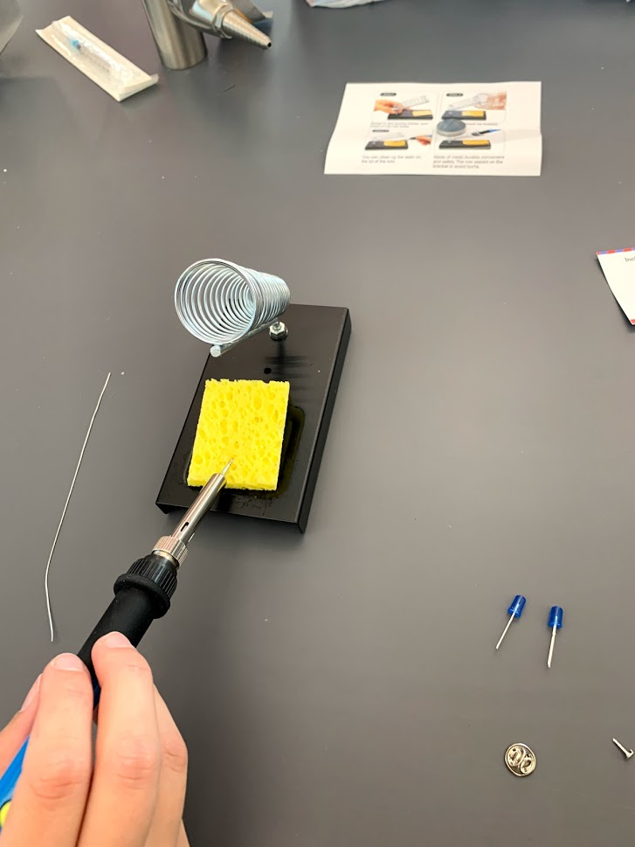

To prime the soldering iron, hold the solder wire in one hand and the iron in the other. Touch the end of the wire on both sides of the iron tip and allow it to flow. If a blob forms on the end, wipe it off on the sponge.

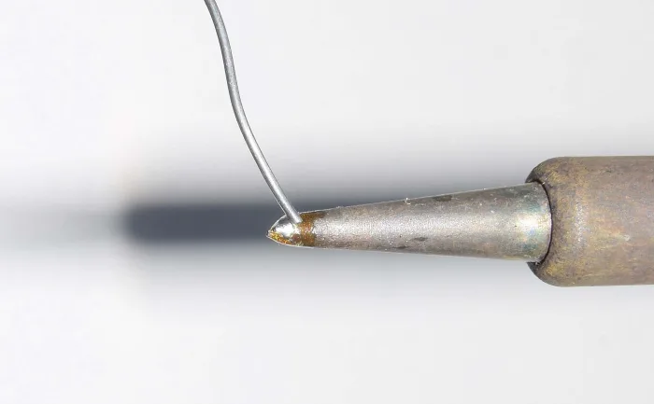

Attach the battery holder on the back and let the legs come through the holes.

Hold the tinned tip of the soldering iron against the leg that comes through the hole. Then, place the wire against the leg, near the iron tip, to melt the wire. Solder all around the leg so it is attached to the badge.

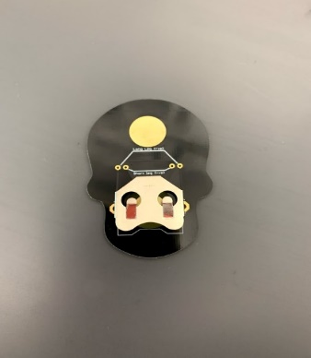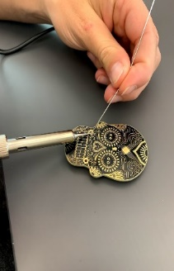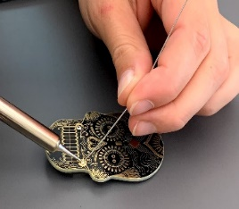

Make sure that the battery holder is attached well and will not fall off. Remember to wet the iron tip regularly to clean off excess wire.

Place the pin on the golden circle on the back of the badge, then hold the soldering iron on the pin and touch the pin with the wire. Solder all around the pin so it will stay on the badge. This can be the trickiest part of this activity – be patient.

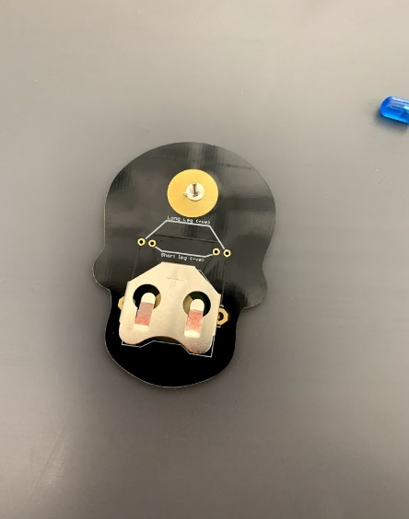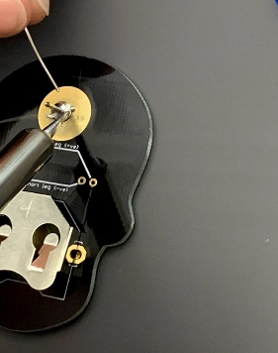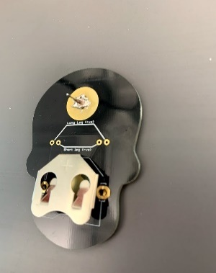

Take the LED lights and insert the legs into the holes, make sure that the short leg goes inside and the long leg outside. Solder the leg on the badge by holding the soldering iron on the leg and then placing the wire on the leg, near the tip of the iron, to melt it. All the gold around the legs should be covered.

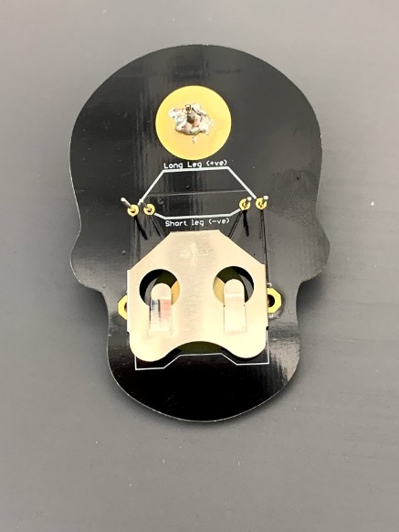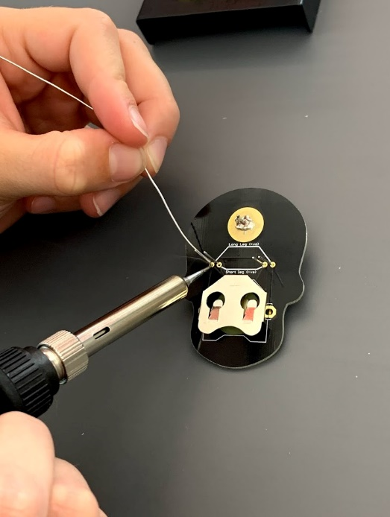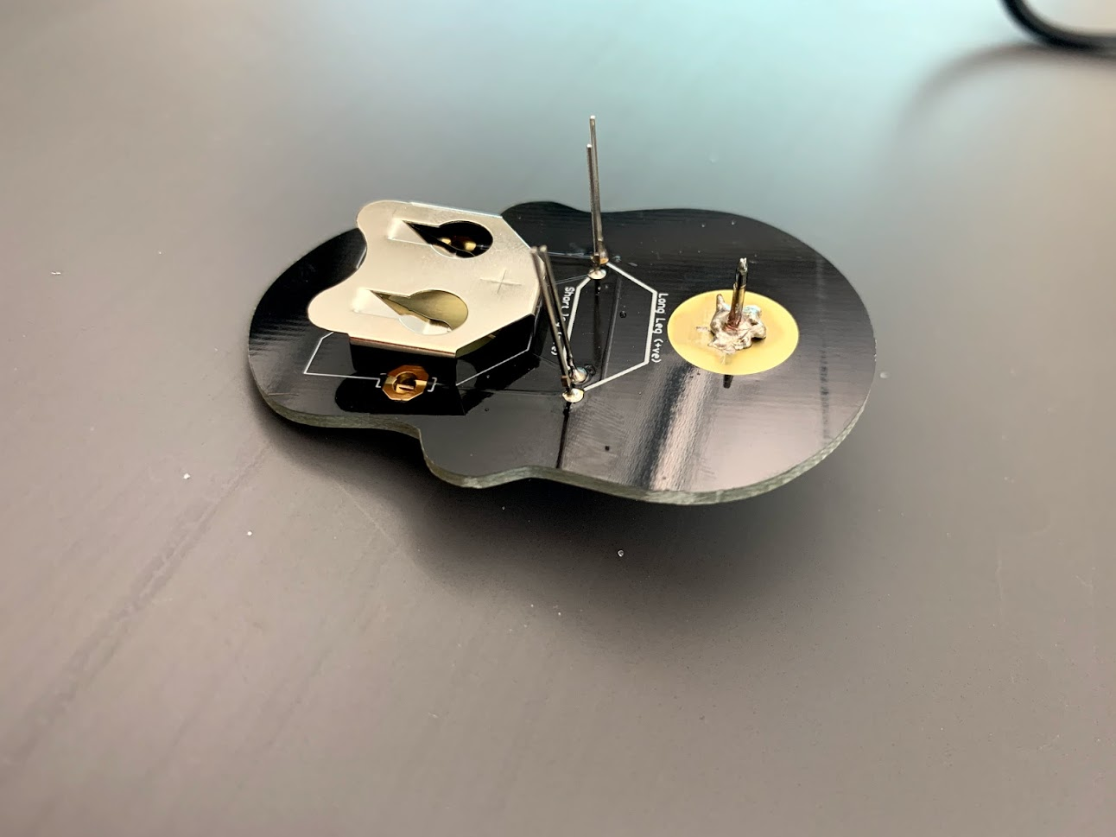

Cut the excess off the legs and insert the battery - amaze your friends and family with your engineering prowess!

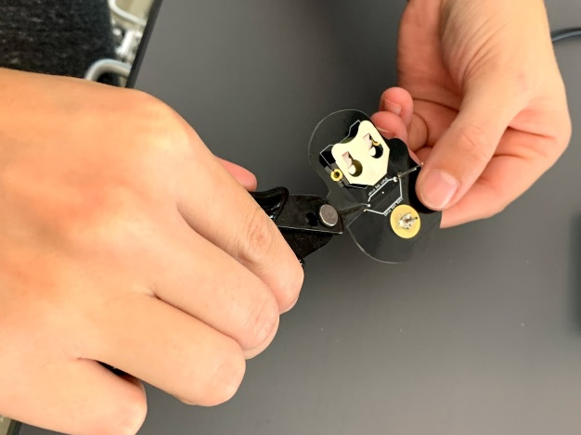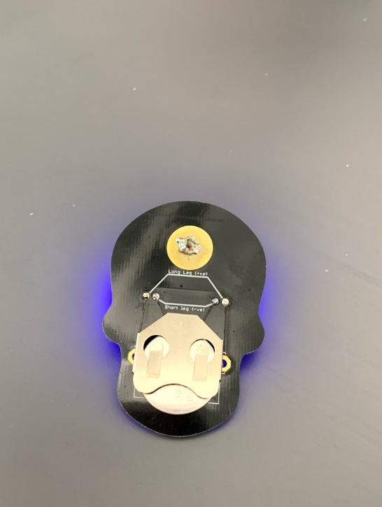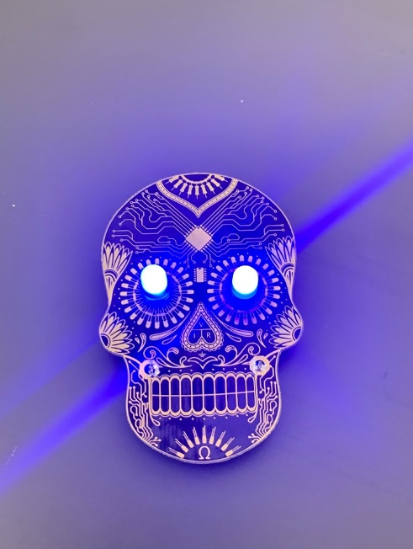

**Additional Resources:**

[’Colin’s Lab: Soldering’ video tutorial](https://learn.adafruit.com/collins-lab-soldering)

[Sparkfun’s ‘How to Solder’](https://learn.sparkfun.com/tutorials/how-to-solder-through-hole-soldering)

[Soldering for kids: A brief tutorial for Parents and Teachers](http://learningtostem.com/soldering-for-kids-guide-for-parents-and-teachers/)

**Questions to Ponder:**

* How did the lights light up?​
* Which profession do you think uses soldering the most?​
* Why may soldering be important in the real world?​

**Science Standards Covered**

* Building your scientific vocabulary.​
* Making connections between science and other subjects.​
* Strengthens knowledge of structure and function of tools.​
* Learned importance of lab/classroom safety.​